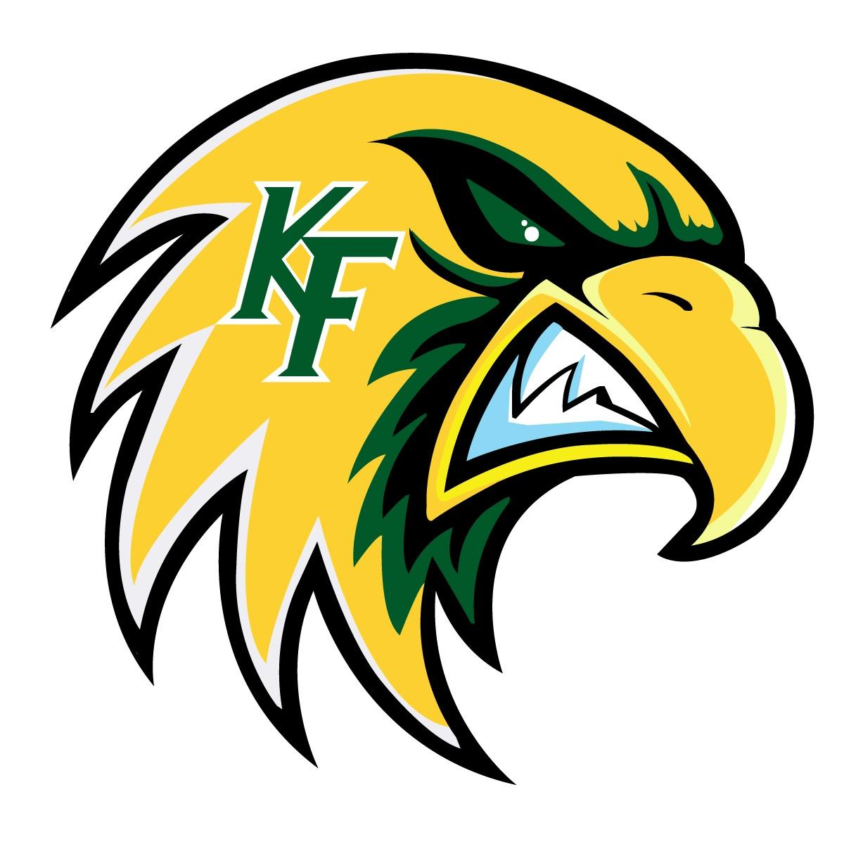


Klein Forest High School Orchestra
Class Reps
2025-26

CHAMBER
Iris Marie Espinosa

SINFONIA
Yannis Rodriguez
Hayden Villegas

PHILHARMONIC
Jaime Gonzalez
Jaqueline Gutierrez

CAMERATA
Nicole Calvillo
Adrian Salazar Martinez

CONCERT
Rudis Cruz
Olivia Phanvilay
Andres Olvera

